

**Kingsway Christian College**

**Maths Department**

**Course**: Mathematics Methods Year 12

**Assessment Task**: Test 4 – Logarithms

**Student Name**: ________________________________________________________

**Date**: 26th June 2017

**Assessment Score**: ____________ / 43

**Year Score**: __________________

**Comments**: ________________________________________________________

___________________________________________________________________________

___________________________________________________________________________

___________________________________________________________________________

___________________________________________________________________________

___________________________________________________________________________

___________________________________________________________________________

___________________________________________________________________________

___________________________________________________________________________

**Teacher signature**: ________________________________________________________

**Parent/ Guardian signature**: _____________________________________________

**Comments**: ________________________________________________________

___________________________________________________________________________

**METHODS YEAR 12 Test 4 2017  
Logarithms**

**Resource Free Time: 35 mins Marks: / 40**

**No notes or calculators allowed for this section.**

**Question 1 (5 marks)**

**Evaluate the following, giving your answer as a single log term:**

$\frac{(log{5-\log{3)²}}}{\log{\frac{3}{5}}}$

**Question 2 (9 marks)**

Solve each of the following equations. Leave answers in logarithmic form where necessary.

**(a) ** (4 marks)

1. $3^{2x+1 }-5\left(3^{x}\right)-2=0$ (5 marks)

**Question 3 (5 marks)**

If $\log_{10}{2=x }$ and $\log_{10}{3=y. }$ Express the following in terms of $x$ and $y$

1. $\log_{10}{0.6}$ (2 marks)
2. $\log_{10}{45 }$ (3 marks)

**Question 4 (3 marks)**

The function $f(x)=\log{(bx-2)}$ is drawn below.

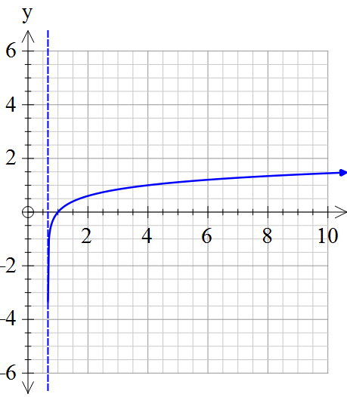

(a) Determine the value of *b.*  (2 marks)

(b) Use the graph to approximate the solution to $\log{(bx-2)}=1$ (1 marks)

**Question 5 (3 marks)**

If $x=\frac{1}{\sqrt{3}}$, show that $\log\left(1-x^{4}\right)- \log\left(1-x\right)- \log\left(1+x\right)=2\log{2- }\log{3.}$

**Question 6 (4 marks)**

State the following as *y* in terms of *x*

$2\log_{2}\left(xy\right)=5\log_{2}{x}$

**Question 7 (9 marks)**

Differentiate each of the following with respect to *x*.

**(a) $y= \sqrt{x }\ln\left(\frac{ x}{3}\right)$** (3 marks)

**(b) $y= \ln\left[ \frac{\left(x+4\right)²}{(3x-1)} \right]$** (3 marks)

1. $y= \frac{cos²x}{\ln{x}}$*(do not simplify)* (3 marks)

**Question 8 (3 marks)**

The tangent to the curve $y= \ln{(kx-1)}$ has a gradient of 1 when $x= 2.$

Determine the value of *k*.

**Question 9 (2 marks)**

Determine the following anti-derivative, simplifying your answer using logarithmic laws if necessary:

$\int{\frac{{5e}^{-2x}}{1+e^{-2x}}}$ $dx$

**EXTRA WORKING**